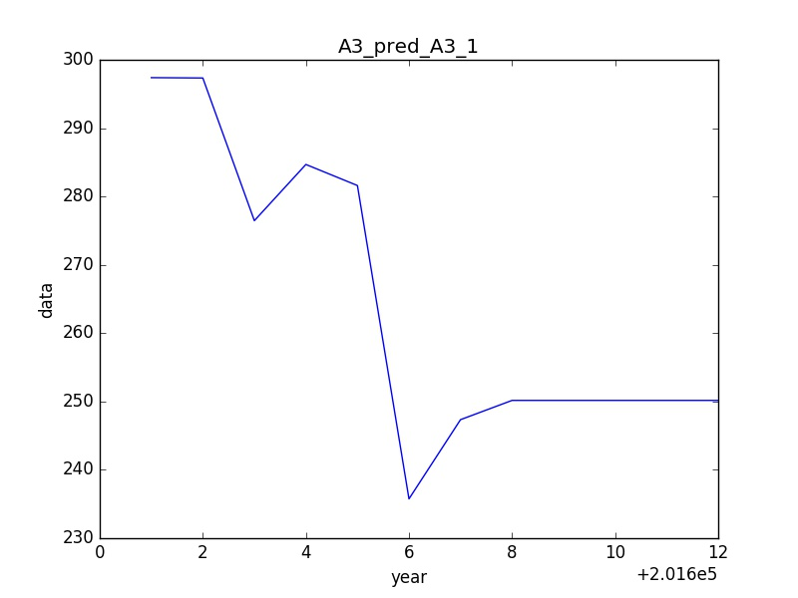

201601: 297.387040044

201602: 297.338653353

201603: 276.461195778

201604: 284.684699341

201605: 281.602107366

201606: 235.751433269

201607: 247.345597846

201608: 250.163619758

201609: 250.163913766

201610: 250.163913766

201611: 250.163913766

201612: 250.163913766

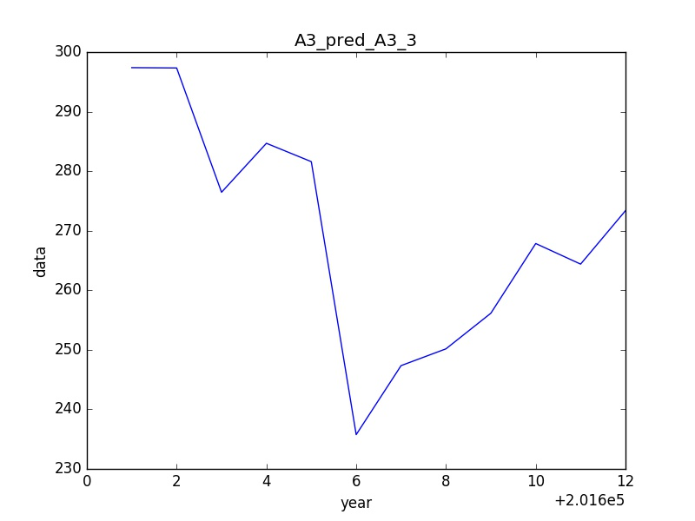

201601: 297.387040044

201602: 297.338653353

201603: 276.461195778

201604: 284.684699341

201605: 281.602107366

201606: 235.751433269

201607: 247.345597846

201608: 250.163619758

201609: 256.142649383

201610: 267.850000088

201611: 264.393796547

201612: 273.371461884

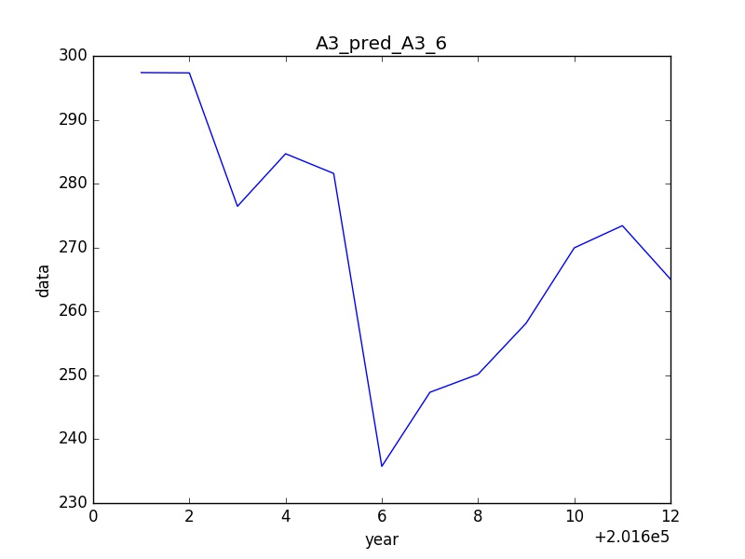

201601: 297.387040044

201602: 297.338653353

201603: 276.461195778

201604: 284.684699341

201605: 281.602107366

201606: 235.751433269

201607: 247.345597846

201608: 250.163619758

201609: 258.163283693

201610: 269.955046775

201611: 273.427668822

201612: 265.05142289